IOT Based Anti-hunt system for trees in Forest

Mr.T Raj Kumar
Assistant Professor
Department of Electronics and Communication Engineering
SRM Institute of Scince and Technology
Chennnai, Tamil Nadu, India
kaviraj27@gmail.com

Nithik Nishanth
Department of Electronics and Communication Engineering
SRM Institute of Science and Technology
Chennai, Tamil Nadu, India
nithiknishanth@gmail.com

Manoj Samuel
Department of Electronics and Communication Engineering
SRM Institute of Science and Technology
Chennai, Tamil Nadu, India
manojsamuel08121998@gmail.com

Modilal S
Department of Electronics and Communication Engineering
SRM Institute of Science and Technology
Chennai, Tamil Nadu, India
modilalsaravanan@gmail.com

P.A. Abeshek
Department of Electronics and Communication Engineering
SRM Institute of Science and Technology
Chennai, Tamil Nadu, India
abeshekabeshekpa@gmail.com

Abstract—In the current scenario there are numerous occurrences regarding the pirating of trees like sandal, sag wan and many more. To limit their sneaking and to spare the woodlands some preventive measures are to be taken. The project aims to limit this unwanted sneaking into the woodlands effectively. The system utilizes three sensors to acknowledge the tendency of the tree after cut, temperature sensor to analyze the timberland fires, a sound sensor to find out about illegal access to the trees. The collected data is placed within the cloud server over the wifi module.
Keywords NodeMCU, Tilt sensor, Sound sensor, WiFi module, Cloud server, temperature sensor.
Introduction
Hunting is not only a problem found in India, it is a major concern in almost all the country with rare forests and wildlife. In India sandalwood is priced at 13000 per kilogram by the government which in a way encourage poachers. The basic goal is to develop a framework which will help; in limiting and preventing over deforestation and poaching. The System is based on the IOT domain.
The system uses NodeMCU as its central system. Multiple sensors are used for detecting various factors like tilt sensors to find the tendency of the tree, a temperature sensor to analyze the fibres of the tree and to check the humidity. Also, a sound sensor is used to find about the activities near the trees. It also helps in finding illegal poaching and all. The entire data is stored into a cloud server for future references. This comprises the monitoring part of the system.
There is also a buzzer attached to the system which helps in alerting the concerned officials incase of breaches around the perimeter. Blynk app is also used for the monitoring and alerting purpose in the project. It also helps in maintaining and watering the plants with the help of the relay board and the water pump.

Overview of the system

Existing System

The existing system is primitive in the aspect that there is no actual method for preventing extensive deforestation. Eventhough cameras are placed by the forest officials, controlling them is a tedious task. Also immediate alerting is not possible with the security cameras.

Proposed System
The proposed system has the following features:
• Uses IOT based NodeMCU system for monitoring and alerting, the data is saved in cloud for future references.
•Uses three tilt sensors for finding the tendency of the tree and sound sensors for alerting officials in case of breach of security.

Arduino Uno
Arduino Uno is an open source microcontroller developed by Arduino cc. It has 14 digital pins and 6 analog pins. It is used as the interface between the hardware and the software.

Dht11 Sensor
This sensor is used here to find the humidity variation of the environment where the crops are cultivated. This is a digital sensor and measures the humidity value in percentage.

Sound Sensor
The sound sensor is one type of module to notice the sound. This module is used to detect the intensity of light. The accuracy of the sensor can be modified as per the usage requirements.

Relay
The main operation of a relay comes in places where only a lower power signal can be used to control a circuit. They help in switching connections as per the power requirements.

Buzzer
A buzzer or beeper is an audio signaling device, which maybe mechanical, electrical or piezoelectric. Typical uses of buzzers and beepers include alarms.

Construction and working
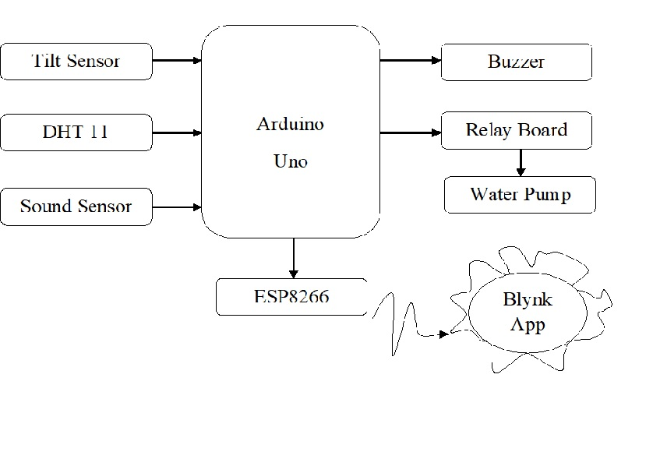

Fig1: Block Diagram

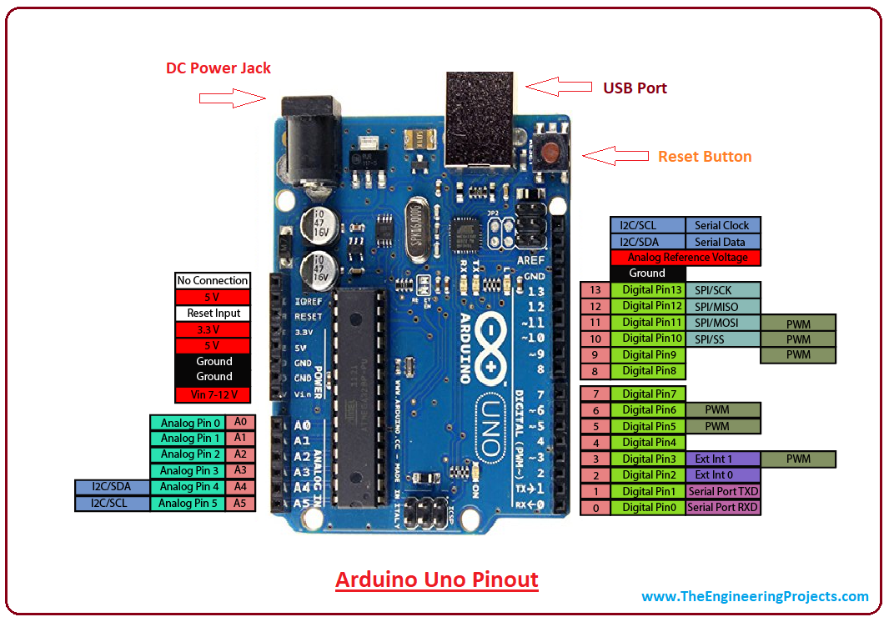

Fig2: Block Diagram of Arduino Uno

The above Fig1 show the implementation of the the project. The main components are tilt sensor, temperature sensor, sound sensor and buzzer. The main components of the project is Arduino Uno. The WiFi module used is NodeMCU. The tilt sensor allows the user to monitor the tendency of the tree. Three tilt sensors are used to cover all the sides of the tree. They monitor for any changes in the tree.

The temperature sensor is placed on the tree for monitoring the tree fibers and also monitors for the humidity around the tree. It is also responsible for watering the tree using the relay option. A sound sensor is also placed in the tree. It is essential in monitoring the surrounding environment. It avoids illegal breaching towards the tree.
A buzzer or beeper is placed to alert the officials in case of illegal cutting of trees or deforestation. The entire data is stored in a cloud server. This is done using the Wifi module and the data stored can be used for future references. The project is based on IOT domain and is helpful in monitoring the cutting of trees.
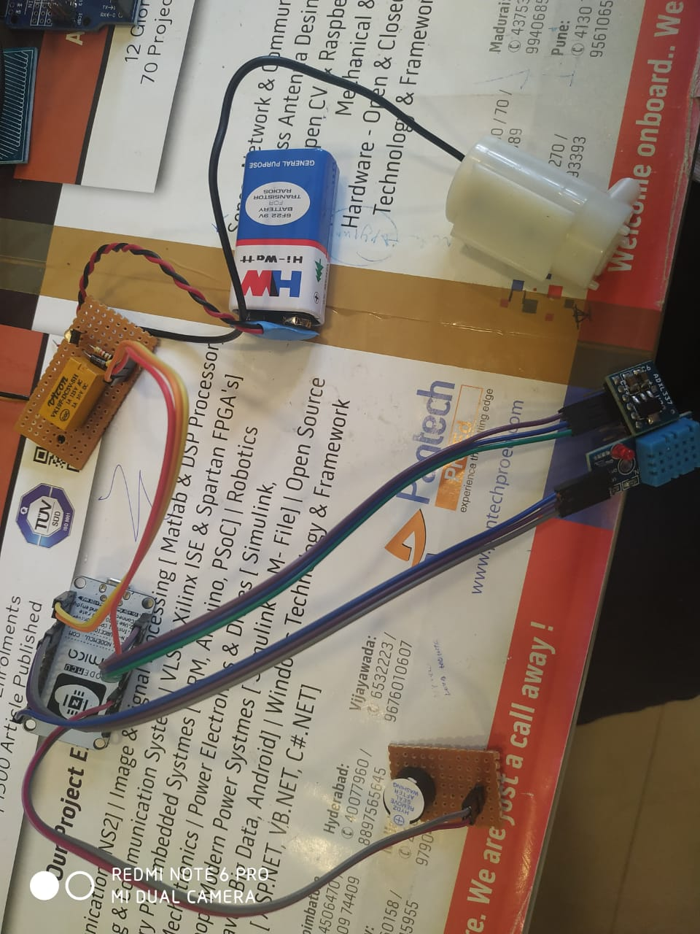

Fig3: Curcuit Layout

future scope

Video cameras can be fixed to the system to give out a video feed on the environment.

Daily water needs can be maintained by implementing monitoring system for finding the water level.

The machine can be extended into taking dailyy care of the trees along with protecting it.

No man power is needed.

Conclusion
In the present; there are no highly efficient methods for monitoring deforestation. The proposed system developed can be a great success as protecting the environment now is of great concern. The system uses three types of sensors for over protection of trees. The temperature around is also monitored and an alarming system is also placed for alerting officials in case of severe incidents. Hence, we successfully studied the program

References
- M.N.N.A. Asghar,M.H., “Principle application and vision in Internet of things(iot) ,” in Communication Technology (GCCT), 2015 Global Conference on, May 2015
- B.R. Pavithra.D., “IOT based monitoring and control system for home automation,” pp.169-173, April 2015.
- T. Ming Zhao, Chua, “Automatic face and gesture recognition,2008 fg,08’, 8th IEEE international conference on”, pp1-6, September 2006
- B.S.S Tharaniya soundhari, M., “Intelligent interface-based speech recognition for home automation using android applicaton,” pp. 1-11 March 2015.

